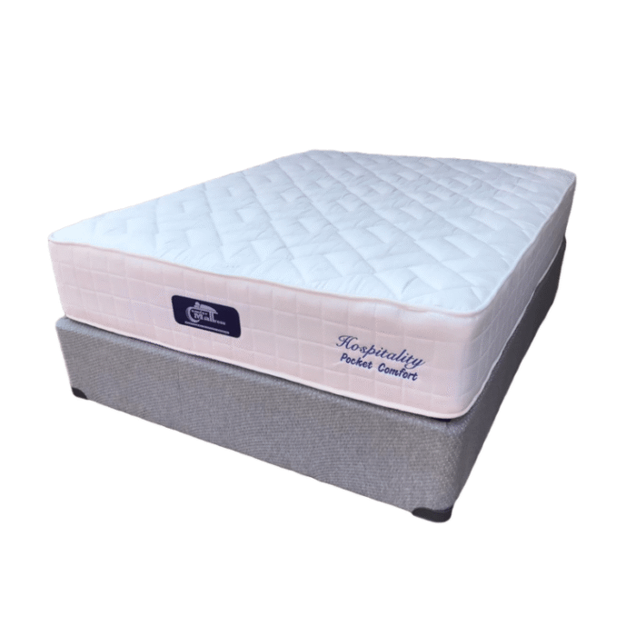
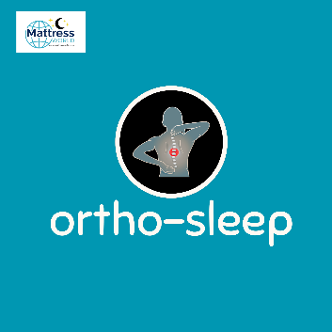

Model : Hospitality-Pocket Comfort 130 Bed Set
Supplier/Manufacturer : Mattress World
Range : Ortho Sleep Range – All Ortho Sleep Range Mattresses are Orthopedic Design. Made stronger to help improve posture, better quality than average mattresses and keep their shape and feel for a longer period of time. Great quality and good for back support.
Features :
- Hospitality Grade Quality
- Heavy Duty Pocket Spring
- High Density Orthopedic Comfort Foam
- Turnable Design
- 130kg Per Person Per Side
- 2 Year Guarantee
- 15 Year Warranty
- Medium Firm Feel
Prices – Bed Set :
- Single Bed Set – R5999
- Three Quarter Bed Set – R6999
- Double Bed Set – R8999
- Queen Bed Set – R8999
- King Bed Set – R10999
Prices – Mattress Only :
- Single Mattress Only – R5499
- Three Quarter Mattress Only – R5999
- Double Mattress Only – R8499
- Queen Mattress Only – R8499
- King Mattress Only – R9999
Prices - Extra Length Bed Set :
- Single Extra Length Bed Set – R7199
- Three Quarter Extra Length Bed Set – R8399
- Double Extra Length Bed Set – R10799
- Queen Extra Length Bed Set – R10799
- King Extra Length Bed Set – R13199
Prices - Extra Length Mattress Only :
- Single Extra Length Mattress Only – R6599
- Three Quarter Extra Length Mattress Only – R7199
- Double Extra Length Mattress Only – R10199
- Queen Extra Length Mattress Only – R10199
- King Extra Length Mattress Only – R11999

